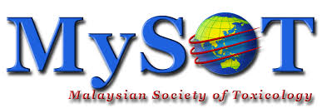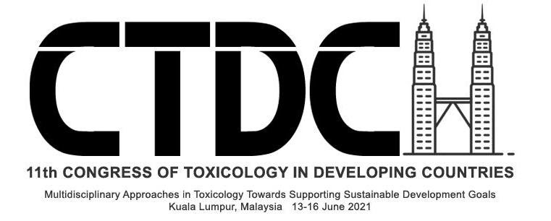

Malaysian Society of Toxicology Fellowships

MySOT Scientific Fellowship
(10; 5 Developed & 5 Non-developing countries)

MySOT Young Toxicologist Fellowship
(15; 5 international & 10 local)

Criteria
- Not more than 35 years old for MySOT Young Toxicologist Fellowship (Students are encouraged to apply)
- Support letter from their respective institute/organization
- Motivation letter for the fellowship
- Brief curriculum vitae
- Copy of an abstract that the applicant has already submitted to CTDC11

Award submissions, including the documents above are to be sent to mysot_secretary@yahoo.com

Award submissions must be received no later than April 7, 2021. Awardees will be notified by May 7, 2021. Awards will be given to cover the registration fees for CTDC11.

Award information is available on the MySOT and CTDC11 websites:
http://mysot.org.my/
http://ctdc11.org/
MySOT Fellowship Award 2021 Application

First Name: M.I.: Last Name:
Organization:
Department:
Address 1:
Address 2:
City: State: Zip Code:
Country:
Phone: Fax:
Email:

Is the candidate a Junior Scientist? Yes No
Is the candidate a Senior Scientist? Yes No
Year PhD Received:
Is Toxicology underrepresented in the candidate’s Country? Yes No
Which Country?
Does the candidate have an active research program? Yes No
Is the candidate currently active in the practice of Toxicology? Yes No

Has the candidate submitted: (attach files to submission email)
1. A brief statement indicating how awardee will benefit from the fellowship? Yes No
2. Curriculum Vitae including an email address and fax (if available)? Yes No
3. A strong letter of recommendation from institute/organisation? Yes No
4. An abstract for the meeting? Yes No

